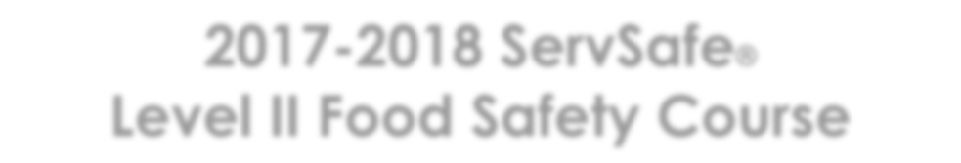
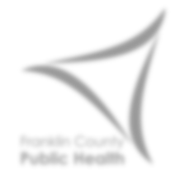
2019 ServSafe®
Level II Food Safety Course
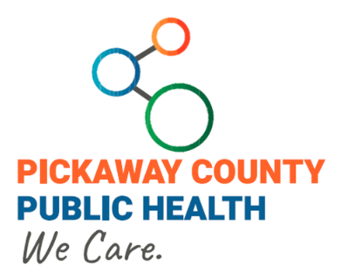

Two Day Course
8:30 a.m. - 5:00 p.m. Each Day

Training Location:
Pickaway County Public Health
110 Island Road
Circleville, OH 43113

Cost:
$120 per person
Please send Cash/Check/Money Order to:
Pickaway County General Health District
PO Box 613
Circleville, Ohio 43113
Training Schedule

 | Day One | Day Two
January | 01/14/19 | 01/18/19
March | 3/11/19 | 3/15/19
May | 5/14/19 | 5/17/19
July | 7/15/19 | 7/19/19
September | 9/9/19 | 9/12/19
November | 11/14/19 | 11/18/19

You must attend both days in order to be able to take the ServSafe exam.

*if you are only retaking the exam, please indicate so on this form and pay the fee of $70.00
 | Registration Information
 | Training Date Requested (from above):
 | Name:
 | Mailing Address:
 | City: |  | State: | Zip:
 | Phone Number: | Email:
 | Food Facility Name:
 | Class size is limited to 24 students. Registration will be on a first-come, first-served basis. Registration MUST be paid in full one week before the first class date. We will not “hold” spots without payment.

**One Registration Form per Person**
**No refunds will be provided after registration forms are received**
If you have any questions, please call 740-477-9667 or email contact@pchd.org.

NOTE: Test can be offered in Spanish or Chinese, please indicate on form if different language is needed.

